CEE 671 Finite Element Analysis----HW#3
Plate with hole
Shibo Wang April 4, 2008

Analyze the problem of a circular hole in a thin plate (e.g. plane stress) that is loaded in tension at the top. For an infinite plate (i.e. width and height that are much larger than the hole) the analytical solution is given below by Kirsch equations: loading an infinite plate with circular hole of radius a with stress σ, the resulting stress field is:
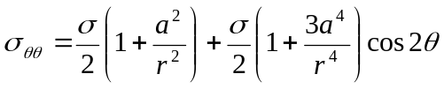
When θ=π/2 x direction
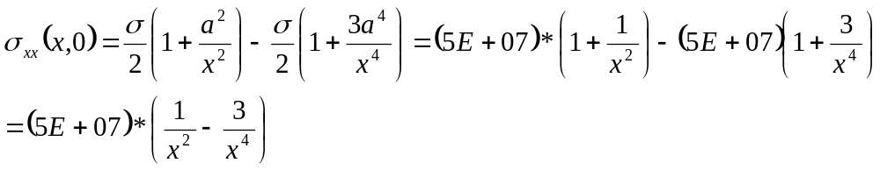
When θ=0 y direction
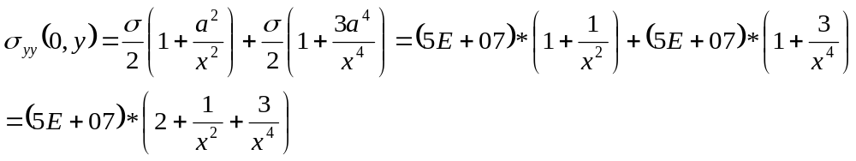
3.1 Determine the mesh that is needed to accurately capture the stress in the plate; your goal is to obtain a solution that is within 5% of the infinite plate solution, for distances that are less than five times the hole radius. (This should require far less than 500 elements). Prove convergence by plotting the stress distribution along the mid-plane of the plate for both the FEA and analytical solutions.
Solutions:
4 scenarios for different mesh geometry have been studied, and the discrepancy within 5-time radius has been calculated.
i. Modified original sample—20 elements, 5 rows, 30 nodes
For stress σ_{yy} :
X | S22 | S22-ANA | DISCREPANCY(%) | 0.95*S22 | 1.05*S22
1 | 2.87E+08 | 3E+08 | -4.192 | 2.85E+08 | 3.15E+08
1.666667 | 1.38E+08 | 1.37E+08 | 0.167362 | 1.31E+08 | 1.44E+08
2.33333 | 1.23E+08 | 1.14E+08 | 8.047574 | 1.09E+08 | 1.2E+08
3 | 1.13E+08 | 1.07E+08 | 5.015103 | 1.02E+08 | 1.13E+08
4 | 1.03E+08 | 1.04E+08 | -0.717318 | 98525391 | 1.09E+08
5 | 9.34E+07 | 1.02E+08 | -8.656201 | 97128000 | 1.07E+08
Plot FEA vs Analytical solutions and compare within the 5% discrepancy
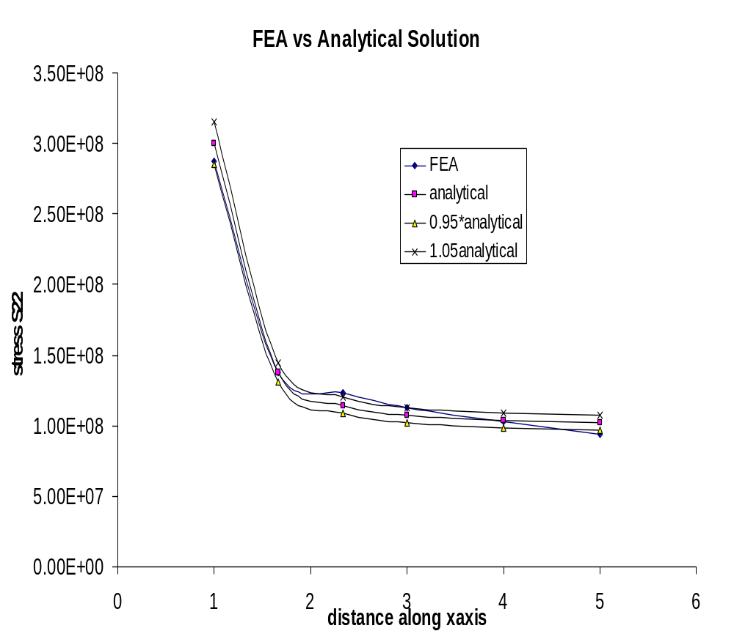
Based on the plot, the results converge and the FEA results are close to analytical solutions.
For stress σ_{xx} :
Y | S11 | S11-ANA | DISCREPANCY(%) | 0.95*S11 | 1.05*S11
1 | -7.92E+07 | -1E+08 | -20.7634 | 95000000 | 105000000
1.666667 | -5.34E+06 | -1439992 | 270.6494 | -1367992 | 1511991.2
2.33333 | -3.60E+06 | 4123279 | -187.321 | 3917115 | 4329443.3
3 | 1.14E+06 | 3703704 | -69.14116 | 3518519 | 3888888.9
4 | 5.51E+06 | 2539063 | 116.984 | 2412109 | 2666015.6
5 | 1.49E+07 | 1760000 | 748.1591 | 1672000 | 1848000
Plot FEA vs Analytical solutions and compare within the 5% discrepancy
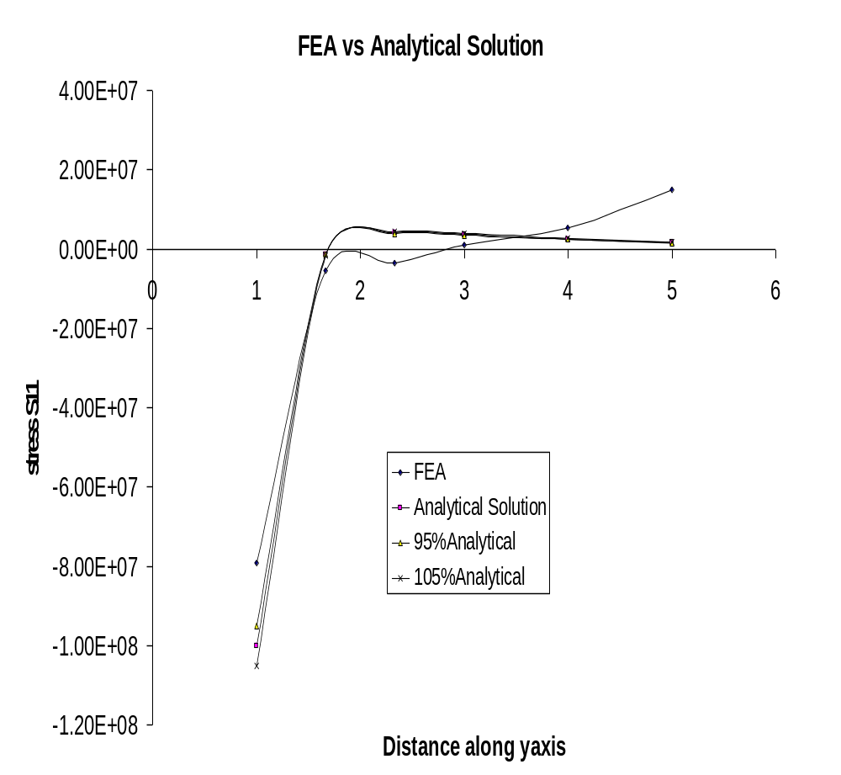
Based on the plot, the FEA results have similar trend as the analytical solution. However, when distance is around 5, the FEA result doesn’t converge. There is a big discrepancy between FEA simulation and analytical solution. This is reasonable because the total distance along both x and y axis are only 5, this is not consistent with the implication of the kirsch equation, which describes the infinite plate.
ii. Try to add more elements and change the mesh density to obtain more accurate results. 225 nodes, 192 elements with 24 rows are applied. Both x and y dimensions are prescribed to be 100 to ensure infinite condition. The second arc is at 10. Between Arc 1 and Arc 2, there are 20 rows and totally 160 elements.
For stress σ_{yy}:
X | S22 | S22-ANA | DISCRE% | 95%ANA | 105%ANA
1 | 2.85E+08 | 3E+08 | -5.027667 | 2.85E+08 | 3.15E+08
1.45 | 1.46E+08 | 1.58E+08 | -7.704439 | 1.50E+08 | 1.66E+08
1.9 | 1.24E+08 | 1.25E+08 | -1.289447 | 1.19E+08 | 1.32E+08
2.35 | 1.14E+08 | 1.14E+08 | -0.030029 | 1.08E+08 | 1.20E+08
2.8 | 1.09E+08 | 1.09E+08 | 0.234391 | 1.03E+08 | 1.14E+08
3.25 | 1.06E+08 | 1.06E+08 | 0.26375 | 1.01E+08 | 1.11E+08
3.7 | 1.05E+08 | 1.04E+08 | 0.237755 | 9.92E+07 | 1.10E+08
4.15 | 1.04E+08 | 1.03E+08 | 0.203188 | 9.82E+07 | 1.09E+08
4.6 | 1.03E+08 | 1.03E+08 | 0.17531 | 9.76E+07 | 1.08E+08
5.05 | 1.02E+08 | 1.02E+08 | 0.157325 | 9.71E+07 | 1.07E+08
5.5 | 1.02E+08 | 1.02E+08 | 0.149469 | 9.67E+07 | 1.07E+08
5.95 | 1.02E+08 | 1.02E+08 | 0.149696 | 9.65E+07 | 1.07E+08
6.4 | 1.01E+08 | 1.01E+08 | 0.158809 | 9.62E+07 | 1.06E+08
6.85 | 1.01E+08 | 1.01E+08 | 0.174308 | 9.61E+07 | 1.06E+08
7.3 | 1.01E+08 | 1.01E+08 | 0.194985 | 9.59E+07 | 1.06E+08
7.75 | 1.01E+08 | 1.01E+08 | 0.221022 | 9.58E+07 | 1.06E+08
8.2 | 1.01E+08 | 1.01E+08 | 0.250274 | 9.57E+07 | 1.06E+08
8.65 | 1.01E+08 | 1.01E+08 | 0.281005 | 9.57E+07 | 1.06E+08
9.1 | 1.01E+08 | 1.01E+08 | 0.31238 | 9.56E+07 | 1.06E+08
9.55 | 1.01E+08 | 1.01E+08 | 0.341801 | 9.55E+07 | 1.06E+08
10 | 1.01E+08 | 1.01E+08 | 0.147242 | 9.55E+07 | 1.06E+08
32.5001 | 1.00E+08 | 1E+08 | 0.035512 | 9.50E+07 | 1.05E+08
55.0001 | 1.00E+08 | 1E+08 | 0.006454 | 9.50E+07 | 1.05E+08
77.5001 | 1.00E+08 | 1E+08 | -0.007328 | 9.50E+07 | 1.05E+08
100.0001 | 1.00E+08 | 1E+08 | -0.0347 | 9.50E+07 | 1.05E+08
Based on the data, it is seen that the accuracy has been improved. Most of the discrepancies are within 5%.
Plot FEA vs Analytical solutions and compare within the 5% discrepancy using data from x=1 to x=8.2
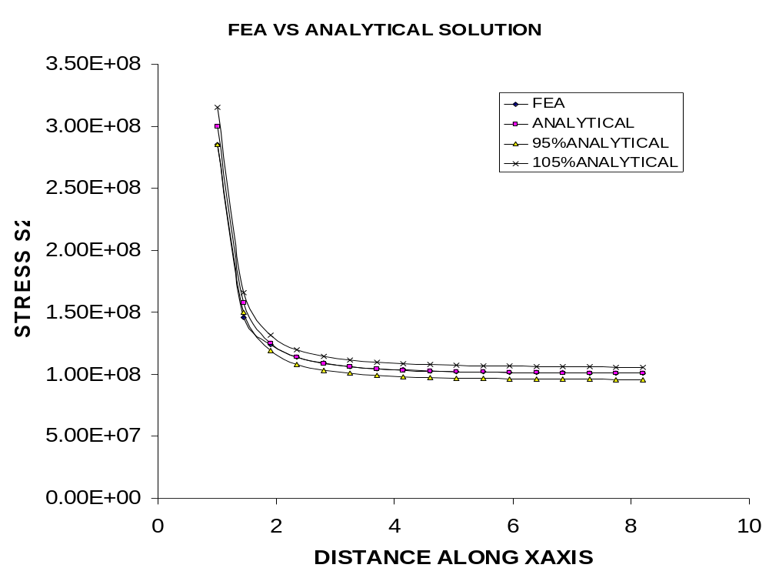
For stress σ_{xx}:
Y | S11 | S11-ANA | DISCRE% | 95%ANA | 105%ANA
1 | -7.99E+07 | -1E+08 | -20.0819 | -95000000 | -105000000
1.45 | -3.72E+06 | -10151552 | -63.3129 | -9643975 | -10659130
1.9 | 1.75E+06 | 2340375 | -25.03893 | 2223356 | 2457393.7
2.35 | 3.02E+06 | 4135516 | -26.95761 | 3928740 | 4342292
2.8 | 2.95E+06 | 3937162 | -25.02035 | 3740304 | 4134019.7
3.25 | 2.58E+06 | 3389237 | -23.87608 | 3219775 | 3558698.9
3.7 | 2.18E+06 | 2851943 | -23.41852 | 2709346 | 2994540
4.15 | 1.83E+06 | 2397472 | -23.55615 | 2277598 | 2517345.7
4.6 | 1.54E+06 | 2027937 | -24.28267 | 1926540 | 2129334.2
5.05 | 1.29E+06 | 1729957 | -25.64612 | 1643459 | 1816454.7
5.5 | 1.08E+06 | 1488969 | -27.72316 | 1414521 | 1563417.8
5.95 | 897037 | 1292649 | -30.60476 | 1228017 | 1357281.6
6.4 | 742295 | 1131296 | -34.38544 | 1074731 | 1187861
6.85 | 606962 | 997458.3 | -39.14914 | 947585.4 | 1047331.3
7.30001 | 487375 | 885439.9 | -44.95674 | 841167.9 | 929711.88
7.75001 | 380958 | 790884.3 | -51.83138 | 751340 | 830428.46
8.20001 | 286029 | 710426.4 | -59.73841 | 674905.1 | 745947.76
8.65001 | 201646 | 641453.4 | -68.5642 | 609380.8 | 673526.1
9.10001 | 127498 | 581916.7 | -78.08999 | 552820.9 | 611012.54
9.55001 | 63806.9 | 530196.1 | -87.96542 | 503686.3 | 556705.91
10.00001 | 189046 | 484999.1 | -61.02137 | 460749.1 | 509249.01
32.5001 | -70589.3 | 47202.54 | -249.5456 | 44842.41 | 49562.666
55.0001 | 7969.73 | 16512.47 | -51.73509 | 15686.85 | 17338.097
77.5001 | 22141.3 | 8320.482 | 166.106 | 7904.458 | 8736.5065
100.0001 | 56414.6 | 4998.49 | 1028.633 | 4748.566 | 5248.4145
Also, the accuracy is improved. This time, the stress within 5-time radius converges.
Plot FEA vs Analytical solutions and compare within the 5% discrepancy using data from y=1 to y=8.2
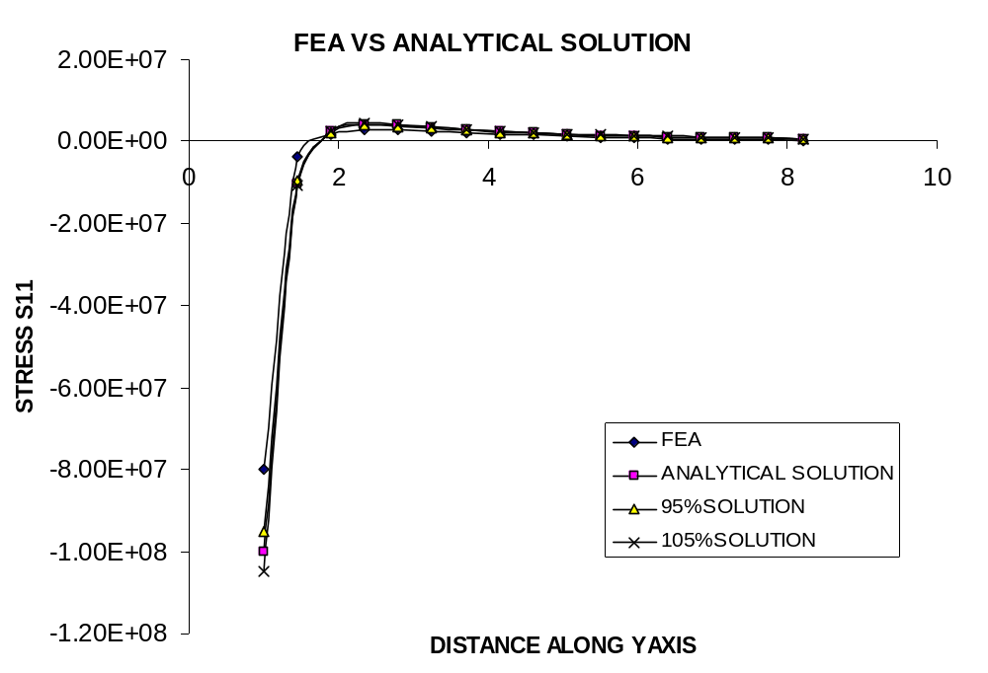
iii. Try to add more elements and change the mesh density to obtain more accurate results. 315 nodes, 272 elements with 34 rows are applied. Both x and y dimensions are prescribed to be 50 to ensure infinite condition. The second arc is at 6. Between Arc 1 and Arc 2, there are 30 rows and totally 240 elements.
For stress σ_{yy}:
X | S22 | S22-ANA | DISCRE | 95%ANA | 105%ANA
1 | 2.98E+08 | 3E+08 | -0.542667 | 2.85E+08 | 315000000
1.166667 | 2.10E+08 | 2.18E+08 | -3.330187 | 2.07E+08 | 228585887
1.333333 | 1.73E+08 | 1.76E+08 | -1.555932 | 1.67E+08 | 184365299
1.5 | 1.51E+08 | 1.52E+08 | -0.541878 | 1.44E+08 | 159444444
1.666667 | 1.37E+08 | 1.37E+08 | 0.019661 | 1.31E+08 | 144311976
1.833333 | 1.29E+08 | 1.28E+08 | 0.31772 | 1.22E+08 | 134561521
2 | 1.22E+08 | 1.22E+08 | 0.465231 | 1.16E+08 | 127968750
2.16667 | 1.18E+08 | 1.17E+08 | 0.530152 | 1.12E+08 | 123330162
2.33333 | 1.15E+08 | 1.14E+08 | 0.54872 | 1.09E+08 | 119956326
2.5 | 1.12E+08 | 1.12E+08 | 0.545422 | 1.06E+08 | 117432000
2.66667 | 1.11E+08 | 1.1E+08 | 0.532261 | 1.04E+08 | 115497402
2.83333 | 1.09E+08 | 1.09E+08 | 0.516823 | 1.03E+08 | 113983756
3 | 1.08E+08 | 1.07E+08 | 0.502379 | 1.02E+08 | 112777778
3.16667 | 1.07E+08 | 1.06E+08 | 0.492277 | 1.01E+08 | 111801726
3.33334 | 1.06E+08 | 1.06E+08 | 0.487185 | 1E+08 | 111000721
3.5 | 1.06E+08 | 1.05E+08 | 0.487988 | 99827155 | 110335277
3.66667 | 1.05E+08 | 1.05E+08 | 0.495596 | 99321417 | 109776303
3.83334 | 1.05E+08 | 1.04E+08 | 0.507881 | 98892445 | 109302176
4 | 1.04E+08 | 1.04E+08 | 0.526524 | 98525391 | 108896484
4.16667 | 1.04E+08 | 1.03E+08 | 0.549773 | 98208775 | 108546541
4.33334 | 1.04E+08 | 1.03E+08 | 0.577063 | 97933711 | 108242522
4.5 | 1.03E+08 | 1.03E+08 | 0.609779 | 97693187 | 107976680
4.66667 | 1.03E+08 | 1.03E+08 | 0.644964 | 97481579 | 107742798
4.83334 | 1.03E+08 | 1.02E+08 | 0.683339 | 97294399 | 107535915
5 | 1.03E+08 | 1.02E+08 | 0.723787 | 97128000 | 107352000
5.16667 | 1.03E+08 | 1.02E+08 | 0.765506 | 96979367 | 107187722
5.33334 | 1.03E+08 | 1.02E+08 | 0.807115 | 96846041 | 107040362
5.5 | 1.03E+08 | 1.02E+08 | 0.847782 | 96725975 | 106907657
5.66667 | 1.03E+08 | 1.02E+08 | 0.886346 | 96617435 | 106787692
5.83334 | 1.03E+08 | 1.02E+08 | 0.921339 | 96518983 | 106678876
6 | 1.02E+08 | 1.02E+08 | 0.39148 | 96429398 | 106579861
17.0001 | 1.00E+08 | 1E+08 | 0.138953 | 95166064 | 105183544
28.0001 | 1.00E+08 | 1E+08 | 0.029962 | 95060818 | 105067220
39.0001 | 1.00E+08 | 1E+08 | -0.029928 | 95031291 | 105034585
50.0001 | 9.99E+07 | 1E+08 | -0.140396 | 95019023 | 105021025
Based on the discrepancy, it can be seen that the accuracy of FEA results are further improved. Not only within 5 times radius the accuracy is obtained, in the whole range of x, the simulation is also very effective. The magnitude of discrepancy is confined within 1.6%.
Plot FEA vs Analytical solutions and compare within the 5% discrepancy using data from x=1 to x=6
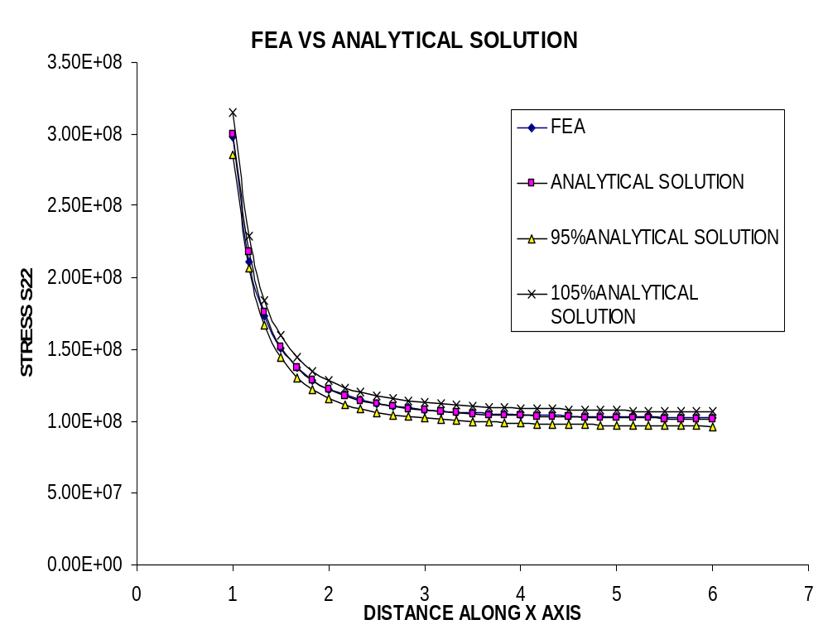
For stress σ_{xx}:
Y | S11 | S11-ANA | DISCRE | 95%ANA | 105%ANA
1 | -9.48E+07 | -1E+08 | -5.2349 | -95000000 | -105000000
1.166667 | -3.95E+07 | -44231499 | -10.755 | -42019924 | -46443074
1.333333 | -1.84E+07 | -19335971 | -5.098637 | -18369172 | -20302769
1.5 | -7.91E+06 | -7407407 | 6.804575 | -7037037 | -7777777.8
1.666667 | -2.54E+06 | -1439992 | 76.30866 | -1367992 | -1511991.2
1.833333 | 283706 | 1598247 | -82.24893 | 1518335 | 1678159.6
2 | 1.76E+06 | 3125000 | -43.63616 | 2968750 | 3281250
2.16667 | 2.50E+06 | 3844412 | -34.8587 | 3652192 | 4036632.9
2.33333 | 2.84E+06 | 4123279 | -31.2278 | 3917115 | 4329443.3
2.5 | 2.93E+06 | 4160000 | -29.49543 | 3952000 | 4368000
2.66667 | 2.90E+06 | 4064939 | -28.73988 | 3861692 | 4268185.6
2.83333 | 2.78E+06 | 3900819 | -28.60884 | 3705778 | 4095860
3 | 2.63E+06 | 3703704 | -28.94518 | 3518519 | 3888888.9
3.16667 | 2.46E+06 | 3494444 | -29.67494 | 3319722 | 3669166.3
3.33334 | 2.27E+06 | 3284992 | -30.7639 | 3120742 | 3449241.3
3.5 | 2.09E+06 | 3082049 | -32.19836 | 2927947 | 3236151.6
3.66667 | 1.91E+06 | 2889143 | -33.97454 | 2744686 | 3033600.3
3.83334 | 1.73E+06 | 2707959 | -36.09505 | 2572561 | 2843357.3
4 | 1.56E+06 | 2539063 | -38.56354 | 2412109 | 2666015.6
4.16667 | 1.40E+06 | 2382333 | -41.38309 | 2263216 | 2501449.6
4.33334 | 1.24E+06 | 2237311 | -44.55398 | 2125445 | 2349176.6
4.5 | 1.09E+06 | 2103338 | -48.07159 | 1998171 | 2208504.8
4.66667 | 951747 | 1979642 | -51.92327 | 1880659 | 2078623.6
4.83334 | 819142 | 1865449 | -56.08876 | 1772177 | 1958721.8
5 | 694562 | 1760000 | -60.53625 | 1672000 | 1848000
5.16667 | 578232 | 1662548 | -65.22014 | 1579421 | 1745675.7
5.33334 | 470467 | 1572415 | -70.07997 | 1493794 | 1651035.5
5.5 | 371690 | 1488969 | -75.0371 | 1414521 | 1563417.8
5.66667 | 282421 | 1411620 | -79.99312 | 1341039 | 1482200.5
5.83334 | 203258 | 1339839 | -84.82967 | 1272847 | 1406830.9
6 | 635870 | 1273148 | -50.0553 | 1209491 | 1336805.6
17.0001 | -198508 | 171212.4 | -215.9425 | 162651.8 | 179773.05
28.0001 | 31205.3 | 63531.02 | -50.88179 | 60354.47 | 66707.57
39.0001 | 90472.1 | 32808.1 | 175.7614 | 31167.7 | 34448.509
50.0001 | 228245 | 19975.92 | 1042.601 | 18977.12 | 20974.716

Plot FEA vs Analytical solutions and compare within the 5% discrepancy using data from y=1 to y=6

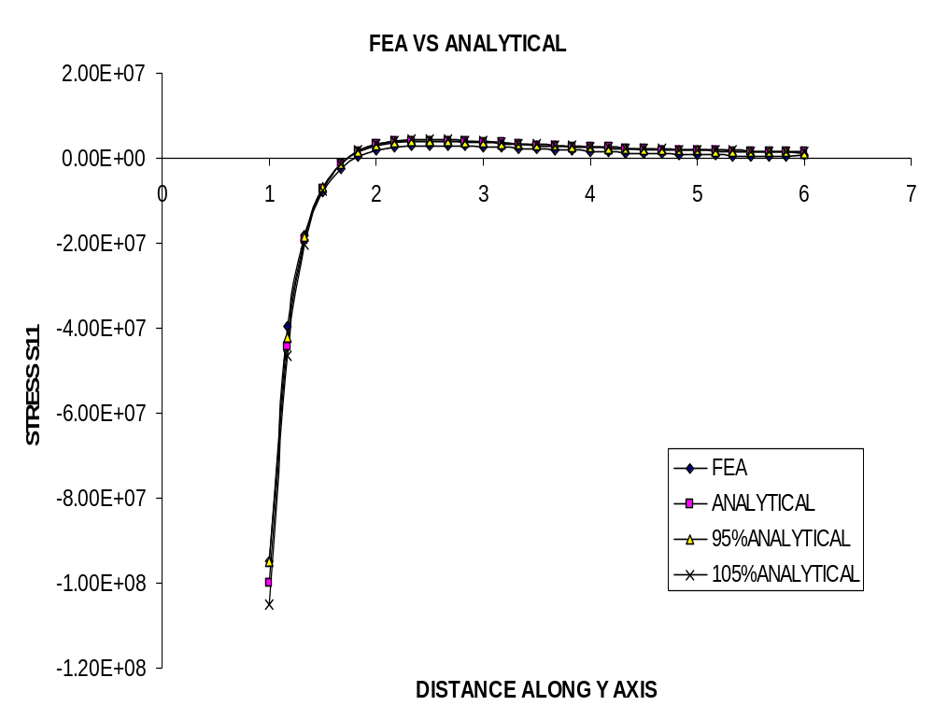
iiii. Try to add more elements and change the mesh density to obtain more accurate results. 495 nodes, 432 elements with 54 rows are applied. Both x and y dimensions are prescribed to be 30 to ensure infinite condition. The second arc is at 5. Between Arc 1 and Arc 2, there are 50 rows and totally 400 elements.
For stress σ_{yy}:
X | S22 | S22-ANA | DISCRE | 95%ANA | 105%ANA
1 | 2.99E+08 | 3E+08 | -0.407333 | 2.85E+08 | 315000000
1.08 | 2.48E+08 | 2.53E+08 | -1.97665 | 2.4E+08 | 265777387
1.16 | 2.17E+08 | 2.2E+08 | -1.298994 | 2.09E+08 | 231001900
1.24 | 1.94E+08 | 1.96E+08 | -0.748733 | 1.86E+08 | 205762462
1.32 | 1.78E+08 | 1.78E+08 | -0.310411 | 1.69E+08 | 187009046
1.4 | 1.65E+08 | 1.65E+08 | 0.031944 | 1.56E+08 | 172784257
1.48 | 1.55E+08 | 1.54E+08 | 0.294715 | 1.46E+08 | 161795414
1.56 | 1.47E+08 | 1.46E+08 | 0.493425 | 1.39E+08 | 153166886
1.64 | 1.40E+08 | 1.39E+08 | 0.641167 | 1.32E+08 | 146291974
1.72 | 1.35E+08 | 1.34E+08 | 0.748501 | 1.27E+08 | 140741697
1.8 | 1.31E+08 | 1.3E+08 | 0.824015 | 1.23E+08 | 136207133
1.88 | 1.27E+08 | 1.26E+08 | 0.876407 | 1.2E+08 | 132462092
1.96 | 1.24E+08 | 1.23E+08 | 0.910489 | 1.17E+08 | 129338438
2.04 | 1.22E+08 | 1.21E+08 | 0.930875 | 1.15E+08 | 126709444
2.12 | 1.20E+08 | 1.19E+08 | 0.942352 | 1.13E+08 | 124478375
2.2 | 1.18E+08 | 1.17E+08 | 0.945887 | 1.11E+08 | 122570521
2.28 | 1.16E+08 | 1.15E+08 | 0.945482 | 1.09E+08 | 120927552
2.36 | 1.15E+08 | 1.14E+08 | 0.941172 | 1.08E+08 | 119503467
2.44 | 1.14E+08 | 1.13E+08 | 0.935676 | 1.07E+08 | 118261654
2.52 | 1.13E+08 | 1.12E+08 | 0.929217 | 1.06E+08 | 117172712
2.6 | 1.12E+08 | 1.11E+08 | 0.922581 | 1.05E+08 | 116212843
2.68 | 1.11E+08 | 1.1E+08 | 0.916383 | 1.04E+08 | 115362637
2.76 | 1.10E+08 | 1.09E+08 | 0.910946 | 1.04E+08 | 114606149
2.84 | 1.09E+08 | 1.09E+08 | 0.90692 | 1.03E+08 | 113930194
2.92 | 1.09E+08 | 1.08E+08 | 0.903915 | 1.03E+08 | 113323799
3 | 1.08E+08 | 1.07E+08 | 0.902724 | 1.02E+08 | 112777778
3.08 | 1.08E+08 | 1.07E+08 | 0.903778 | 1.02E+08 | 112284398
3.16 | 1.07E+08 | 1.07E+08 | 0.905498 | 1.01E+08 | 111837117
3.24 | 1.07E+08 | 1.06E+08 | 0.910104 | 1.01E+08 | 111430368
3.32 | 1.07E+08 | 1.06E+08 | 0.915325 | 1E+08 | 111059396
3.4 | 1.06E+08 | 1.05E+08 | 0.922986 | 1E+08 | 110720118
3.48 | 1.06E+08 | 1.05E+08 | 0.931567 | 99893872 | 110409016
3.56 | 1.06E+08 | 1.05E+08 | 0.942905 | 99635135 | 110123044
3.64 | 1.06E+08 | 1.05E+08 | 0.954669 | 99396740 | 109859554
3.72 | 1.05E+08 | 1.04E+08 | 0.968023 | 99176598 | 109616240
3.8 | 1.05E+08 | 1.04E+08 | 0.981953 | 98972882 | 109391080
3.88 | 1.05E+08 | 1.04E+08 | 0.997137 | 98783988 | 109182303
3.96 | 1.05E+08 | 1.04E+08 | 1.014059 | 98608502 | 108988344
4.04 | 1.05E+08 | 1.04E+08 | 1.031107 | 98445175 | 108807825
4.12 | 1.05E+08 | 1.03E+08 | 1.048448 | 98292900 | 108639521
4.2 | 1.04E+08 | 1.03E+08 | 1.066122 | 98150693 | 108482345
4.28001 | 1.04E+08 | 1.03E+08 | 1.084076 | 98017664 | 108335312
4.36001 | 1.04E+08 | 1.03E+08 | 1.10211 | 97893061 | 108197593
4.44001 | 1.04E+08 | 1.03E+08 | 1.119019 | 97776166 | 108068394
4.52001 | 1.04E+08 | 1.03E+08 | 1.136418 | 97666352 | 107947020
4.6 | 1.04E+08 | 1.03E+08 | 1.15196 | 97563063 | 107832859
4.68 | 1.04E+08 | 1.03E+08 | 1.166191 | 97465763 | 107725317
4.76001 | 1.04E+08 | 1.02E+08 | 1.179581 | 97373995 | 107623889
4.84001 | 1.04E+08 | 1.02E+08 | 1.19156 | 97287363 | 107528138
4.92001 | 1.04E+08 | 1.02E+08 | 1.201552 | 97205476 | 107437631
5.00001 | 1.03E+08 | 1.02E+08 | 0.572193 | 97127991 | 107351990
11.2501 | 1.01E+08 | 1E+08 | 0.336221 | 95384198 | 105424640
17.5001 | 1.00E+08 | 1E+08 | 0.087992 | 95156620 | 105173106
23.7501 | 1.00E+08 | 1E+08 | -0.087036 | 95084658 | 105093569
30.0001 | 9.97E+07 | 1E+08 | -0.383027 | 95052953 | 105058527
This time, the simulation results are very consistent with the analytical solutions.
Plot FEA vs Analytical solutions and compare within the 5% discrepancy using data from x=1 to x=5
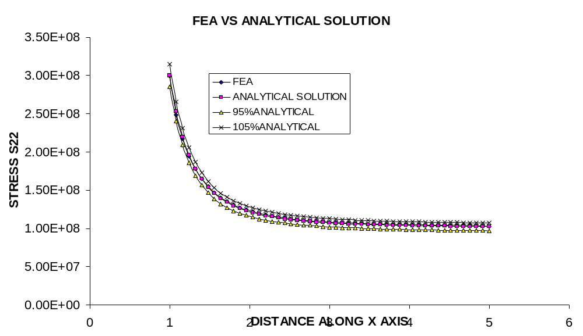
For stress σ_{xx}:
Y | S11 | S11-ANA | DISCRE | 95%ANA | 105%ANA
1 | -9.69E+07 | -1E+08 | -3.0702 | -95000000 | -105000000
1.08 | -6.37E+07 | -67387471 | -5.423369 | -64018098 | -70756845
1.16 | -4.40E+07 | -45685520 | -3.721791 | -43401244 | -47969796
1.24 | -3.05E+07 | -30927829 | -1.465119 | -29381438 | -32474221
1.32 | -2.11E+07 | -20711751 | 1.694446 | -19676163 | -21747338
1.4 | -1.44E+07 | -13536027 | 6.431528 | -12859225 | -14212828
1.48 | -9.64E+06 | -8437109 | 14.27232 | -8015253 | -8858964.1
1.56 | -6.20E+06 | -4781838 | 29.57967 | -4542746 | -5020929.9
1.64 | -3.69E+06 | -2145440 | 71.87712 | -2038168 | -2252711.7
1.72 | -1.85E+06 | -237656.4 | 679.15 | -225773.6 | -249539.24
1.8 | -505383 | 1143118 | -144.2109 | 1085963 | 1200274.3
1.88 | 481159 | 2138972 | -77.50513 | 2032023 | 2245920.4
1.96 | 1.20E+06 | 2851356 | -57.8853 | 2708788 | 2993923.8
2.04 | 1.72E+06 | 3353559 | -48.68019 | 3185881 | 3521236.8
2.12 | 2.09E+06 | 3699077 | -43.46915 | 3514124 | 3884031.3
2.2 | 2.35E+06 | 3927327 | -40.22373 | 3730961 | 4123693.7
2.28 | 2.52E+06 | 4067592 | -38.10219 | 3864212 | 4270971.1
2.36 | 2.62E+06 | 4141785 | -36.69275 | 3934695 | 4348873.9
2.44 | 2.68E+06 | 4166414 | -35.7709 | 3958093 | 4374734.3
2.52 | 2.69E+06 | 4153981 | -35.20481 | 3946282 | 4361680
2.6 | 2.68E+06 | 4114002 | -34.91203 | 3908302 | 4319701.7
2.68 | 2.64E+06 | 4053745 | -34.83877 | 3851057 | 4256431.9
2.76 | 2.59E+06 | 3978781 | -34.94866 | 3779842 | 4177719.6
2.84 | 2.52E+06 | 3893387 | -35.21681 | 3698717 | 4088056
2.92 | 2.45E+06 | 3800852 | -35.62522 | 3610809 | 3990894.2
3 | 2.36E+06 | 3703704 | -36.16093 | 3518519 | 3888888.9
3.08 | 2.28E+06 | 3603885 | -36.81429 | 3423690 | 3784078.7
3.16 | 2.19E+06 | 3502881 | -37.57795 | 3327737 | 3678025.1
3.24 | 2.09E+06 | 3401827 | -38.44631 | 3231736 | 3571918.4
3.32 | 2.00E+06 | 3301581 | -39.41418 | 3136502 | 3466660.3
3.4 | 1.91E+06 | 3202787 | -40.47747 | 3042648 | 3362926.7
3.48 | 1.81E+06 | 3105921 | -41.63278 | 2950625 | 3261217.6
3.56 | 1.72E+06 | 3011329 | -42.87571 | 2860762 | 3161895
3.64 | 1.63E+06 | 2919251 | -44.20246 | 2773288 | 3065213.2
3.72 | 1.54E+06 | 2829850 | -45.60878 | 2688358 | 2971342.5
3.8 | 1.45E+06 | 2743226 | -47.08967 | 2606065 | 2880387.7
3.88 | 1.37E+06 | 2659431 | -48.63976 | 2526459 | 2792402.4
3.96 | 1.28E+06 | 2578477 | -50.25242 | 2449553 | 2707401.2
4.04 | 1.20E+06 | 2500351 | -51.92075 | 2375333 | 2625368.3
4.12 | 1.12E+06 | 2425014 | -53.63615 | 2303764 | 2546265.1
4.2 | 1.05E+06 | 2352415 | -55.38882 | 2234794 | 2470035.6
4.28001 | 977634 | 2282479 | -57.16788 | 2168355 | 2396602.5
4.36001 | 909070 | 2215149 | -58.96122 | 2104391 | 2325906.3
4.44001 | 843908 | 2150337 | -60.75462 | 2042820 | 2257853.8
4.52001 | 782307 | 2087959 | -62.53246 | 1983561 | 2192357.3
4.6 | 724434 | 2027937 | -64.2773 | 1926540 | 2129334.2
4.68 | 670456 | 1970169 | -65.96962 | 1871661 | 2068677.7
4.76001 | 620544 | 1914570 | -67.58833 | 1818841 | 2010298
4.84001 | 574872 | 1861066 | -69.11061 | 1768013 | 1954119.6
4.92001 | 533610 | 1809568 | -70.51175 | 1719090 | 1900046.9
5.00001 | 1.17E+06 | 1759994 | -33.635 | 1671994 | 1847993.6
11.2501 | -250927 | 385690.6 | -165.0591 | 366406.1 | 404975.14
17.5001 | 92534.5 | 161664.1 | -42.76127 | 153580.9 | 169747.35
23.7501 | 259337 | 88170.47 | 194.1314 | 83761.95 | 92578.993
30.0001 | 627931 | 55370 | 1034.064 | 52601.5 | 58138.503
Plot FEA vs Analytical solutions and compare within the 5% discrepancy using data from y=1 to y=5
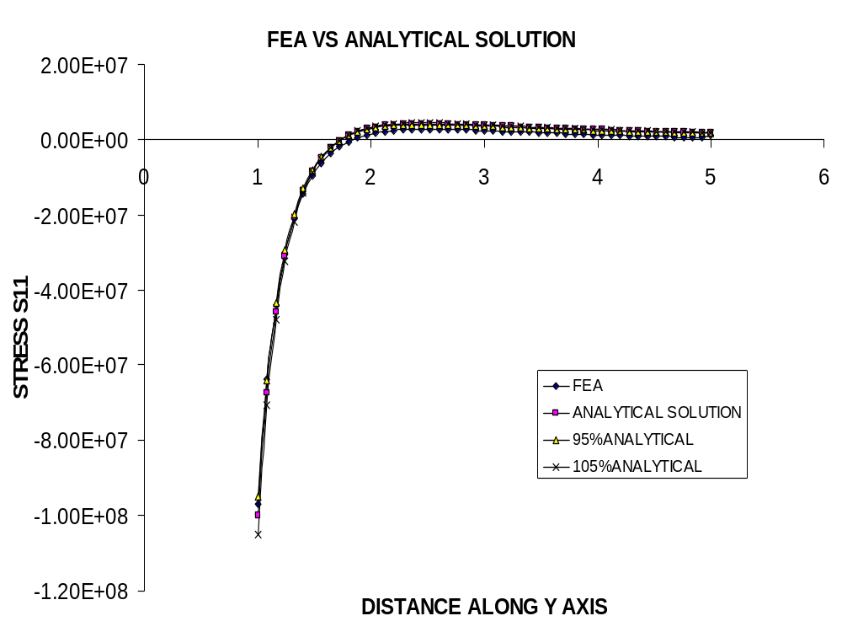
Generally, in this question, it is found that with the increasing mesh density, the accuracy and convergence have been gradually improved.

3.2 Compare the performance of four-noded and eight-noded quadrilaterals, and identify the coarsest mesh that produces the correct value (i.e. within 5%) of the maximum tensile stress near the edge of the hole. Illustrate the differences between different stress quantities (i.e. elemental averages, stresses at the nodes, etc.) by plotting several curves with each type of calculated stress: superimpose the analytical solution over the numerical results.
Solution:
Since 4-noded elements are replaced by 8-noded elements, it can be expected that the simulation results should be more accurate. This is because 4-noded element simulation is based on first-order interpolation, and 8-noded element simulation is based on second-order interpolation. 3 scenarios for different mesh geometries have been studied. One is used to compare the performance between 4-noded and 8-noded FEA results, and the other is used to find the maximum tensile stress near the hole edge within 5% discrepancy.
i. Modified original sample—20 elements, 5 rows, 99 nodes
For stress σ_{yy} :
X | S22 | S22-ANA | DISCRE% | 95%ANA | 105%ANA
1 | 3.27E+08 | 3E+08 | 9.005333 | 2.85E+08 | 315000000
1.66657 | 1.47E+08 | 1.37E+08 | 7.306402 | 1.31E+08 | 144318929
1.666667 | 1.47E+08 | 1.37E+08 | 7.314482 | 1.31E+08 | 144311976
2.33324 | 1.17E+08 | 1.14E+08 | 2.420566 | 1.09E+08 | 119957890
2.9999 | 1.07E+08 | 1.07E+08 | -0.667571 | 1.02E+08 | 112778426
3.99997 | 9.78E+07 | 1.04E+08 | -5.745198 | 98525452 | 108896552
5 | 8.41E+07 | 1.02E+08 | -17.73905 | 97128000 | 107352000
Plot FEA vs Analytical solutions and compare within the 5% discrepancy
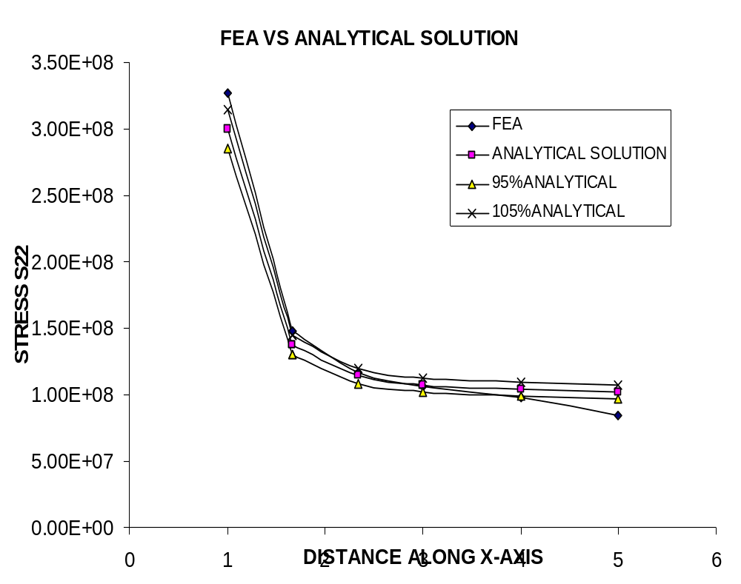

Based on the plot, the FEA results are close to analytical solutions. Improvements of accuracy are observed compared with 4-noded case. The maximum tensile stress near the hole is found to be around x=1.0, which has the value of stress σ_{yy} = 3.27*E08. However, the discrepancy of 9.01% doesn’t satisfy the requirement. Plot the 8-noded results and compare the 4-noded scenario.
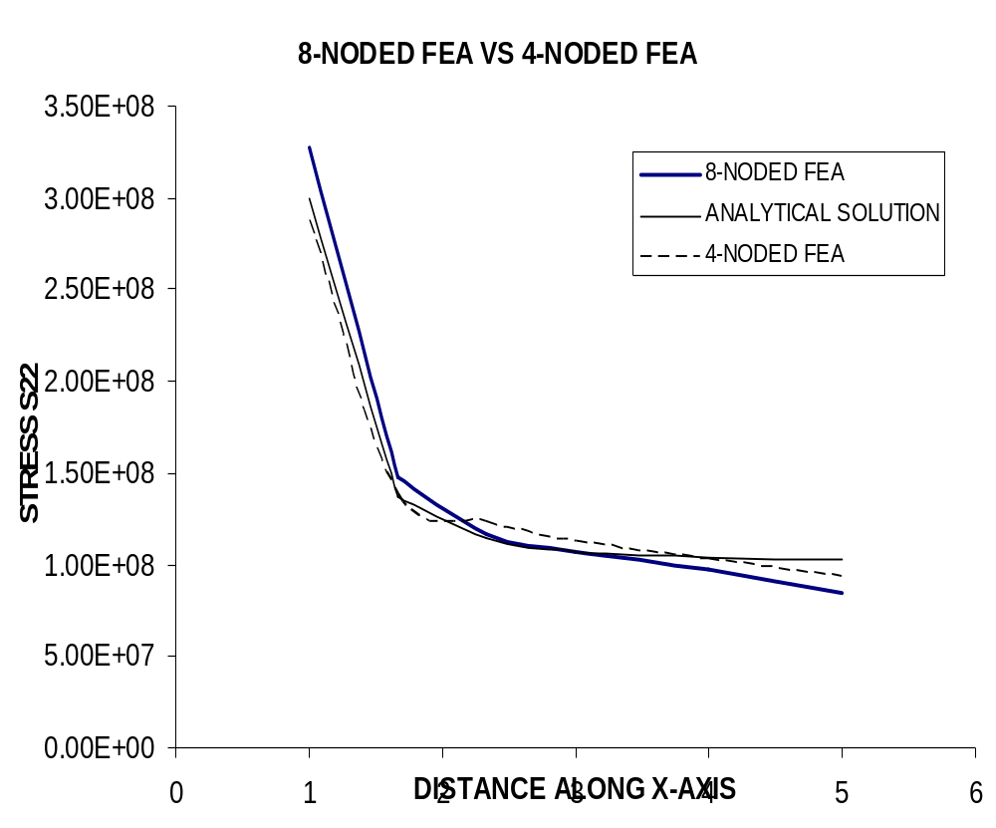
Based on the plot, both the FEA results of 4-noded and 8-noded have similar trend as the analytical solution. However, when distance is around 5, the FEA results of both cases do not converge. There is a relatively big discrepancy between FEA simulation and analytical solution. This is reasonable because the total distance along both x and y axis are only 5, this is not consistent with the implication of the kirsch equation, which describes the infinite plate.
For stress σ_{xx} :
Y | S11 | S11-ANA | DISCRE% | 95%ANA | 105%ANA
1 | -1.18E+08 | -1E+08 | 17.941 | -95000000 | -105000000
1.66657 | -4.47E+06 | -1442423 | 210.2149 | -1370301 | -1514543.7
1.666667 | -4.48E+06 | -1439992 | 211.0358 | -1367992 | -1511991.2
2.33324 | 5.84E+06 | 4123207 | 41.74816 | 3917047 | 4329367.3
2.9999 | 8.69E+06 | 3703827 | 134.5139 | 3518636 | 3889018.5
3.99997 | 1.41E+07 | 2539092 | 454.781 | 2412137 | 2666046.4
5 | 2.96E+07 | 1760000 | 1581.364 | 1672000 | 1848000
Plot FEA vs Analytical solutions and compare within the 5% discrepancy
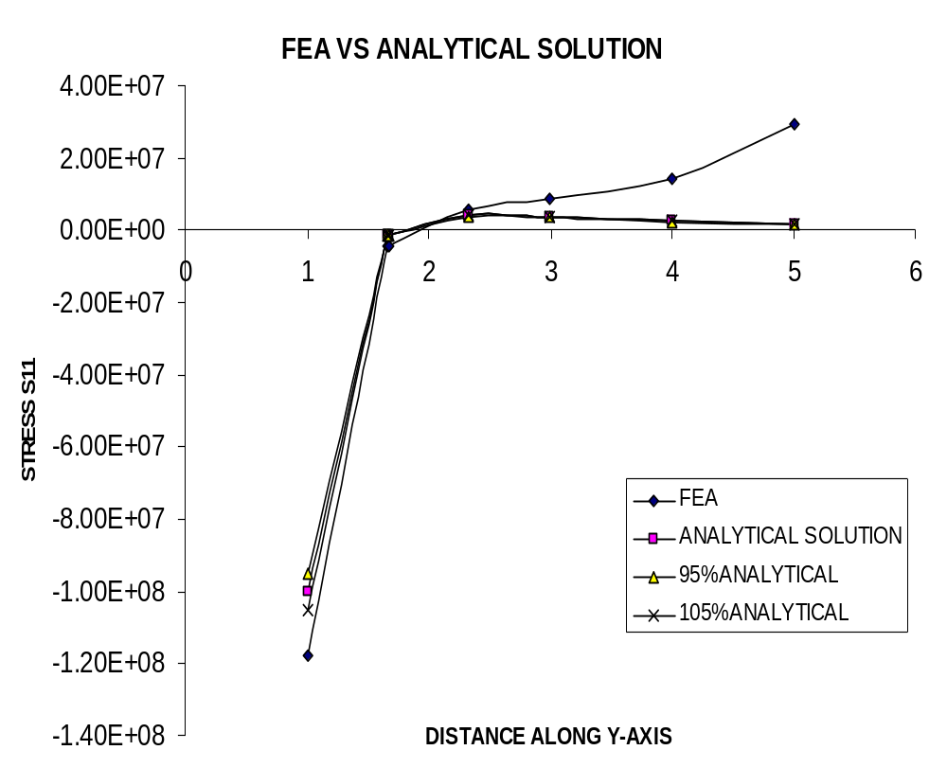

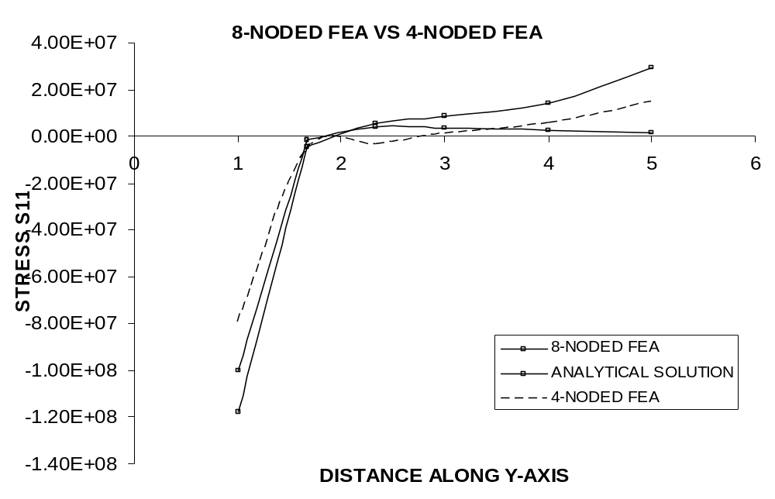
Based on the plot, the conclusion is similar to that for the S22. At some places along the x axis, the result of 8-noded case is better than that of 4-noded, while for the other places, 4-noded case is in turn better than that of 8-noded one.
ii. Change the mesh density to improve the accuracy: 833 nodes, 192 elements with 24 rows contained. Both x and y dimensions are prescribed to be 20 to ensure infinite condition. The second arc is at 6. Between Arc 1 and Arc 2, there are 20 rows and totally 160 elements.
For stress σ_{yy} :
X | S22 | S22-ANA | DISCRE% | 95%ANA | 105%ANA
1 | 3.03E+08 | 3E+08 | 1.101 | 2.85E+08 | 315000000
1.249952 | 1.95E+08 | 1.93E+08 | 0.837988 | 1.84E+08 | 203124491
1.25 | 1.95E+08 | 1.93E+08 | 0.839537 | 1.84E+08 | 203112000
1.499952 | 1.52E+08 | 1.52E+08 | 0.005224 | 1.44E+08 | 159449920
1.5 | 1.52E+08 | 1.52E+08 | 0.006024 | 1.44E+08 | 159444444
1.749952 | 1.32E+08 | 1.32E+08 | -0.22711 | 1.26E+08 | 138938643
1.75 | 1.32E+08 | 1.32E+08 | -0.226623 | 1.26E+08 | 138935860
1.999951 | 1.22E+08 | 1.22E+08 | -0.2351 | 1.16E+08 | 127970358
2.24995 | 1.16E+08 | 1.16E+08 | -0.173912 | 1.1E+08 | 121516782
2.49995 | 1.12E+08 | 1.12E+08 | -0.095339 | 1.06E+08 | 117432659
2.74995 | 1.09E+08 | 1.09E+08 | -0.019932 | 1.04E+08 | 114696512
2.99995 | 1.07E+08 | 1.07E+08 | 0.046816 | 1.02E+08 | 112778102
3.24995 | 1.06E+08 | 1.06E+08 | 0.104218 | 1.01E+08 | 111382369
3.49995 | 1.05E+08 | 1.05E+08 | 0.151892 | 99827320 | 110335459
3.74995 | 1.05E+08 | 1.04E+08 | 0.191528 | 99098499 | 109529920
3.99995 | 1.04E+08 | 1.04E+08 | 0.224619 | 98525493 | 108896597
4.24995 | 1.03E+08 | 1.03E+08 | 0.250884 | 98066617 | 108389418
4.49995 | 1.03E+08 | 1.03E+08 | 0.271304 | 97693255 | 107976755
4.74995 | 1.03E+08 | 1.03E+08 | 0.287987 | 97385243 | 107636322
4.99995 | 1.03E+08 | 1.02E+08 | 0.299247 | 97128047 | 107352052
5.24995 | 1.02E+08 | 1.02E+08 | 0.307269 | 96910972 | 107112127
Based on the results, it is seen that the discrepancy is far below 5% at the maximum stress spot.
Plot 8-noded FEA vs Analytical solutions and compare the results with that of 4-noded case. It is observed that the FEA curve matches that of analytical solution very well, while the 4-noded curve is not as good. The 8-noded simulation has very high accuracy.
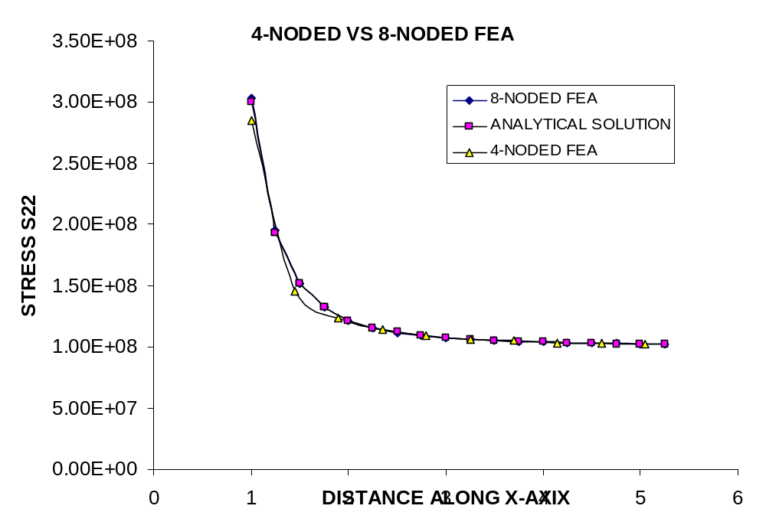
For stress σ_{xx} :
Y | S11 | S11-ANA | DISCRE% | 95%ANA | 105%ANA
1 | -1.02E+08 | -1E+08 | 2.241 | -95000000 | -105000000
1.249509 | -3.04E+07 | -29511475 | 2.917254 | -28035902 | -30987049
1.249958 | -3.03E+07 | -29446108 | 3.005804 | -27973802 | -30918413
1.499509 | -7.06E+06 | -7431679 | -5.059677 | -7060095 | -7803262.9
1.499965 | -7.04E+06 | -7409136 | -4.982847 | -7038679 | -7779592.7
1.749509 | 890408 | 324398.2 | 174.48 | 308178.3 | 340618.1
1.749969 | 897610 | 332639.7 | 169.8446 | 316007.7 | 349271.63
1.999509 | 3.64E+06 | 3121928 | 16.44311 | 2965831 | 3278024.3
1.999973 | 3.64E+06 | 3124831 | 16.43125 | 2968590 | 3281072.8
2.24951 | 4.44E+06 | 4022979 | 10.32273 | 3821830 | 4224127.8
2.24998 | 4.44E+06 | 4023744 | 10.32833 | 3822557 | 4224931.6
2.49951 | 4.48E+06 | 4160125 | 7.627057 | 3952119 | 4368131.1
2.74951 | 4.22E+06 | 3989285 | 5.81244 | 3789821 | 4188749.4
2.99951 | 3.86E+06 | 3704309 | 4.330941 | 3519093 | 3889524
3.24951 | 3.49E+06 | 3389854 | 2.999137 | 3220361 | 3559346.3
3.49951 | 3.14E+06 | 3082632 | 1.743241 | 2928501 | 3236763.9
3.74951 | 2.81E+06 | 2797570 | 0.531897 | 2657691 | 2937448.3
3.99951 | 2.52E+06 | 2539541 | -0.643859 | 2412564 | 2666518.1
4.24951 | 2.27E+06 | 2308828 | -1.780462 | 2193386 | 2424269.2
4.49951 | 2.04E+06 | 2103716 | -2.866658 | 1998531 | 2208902.2
4.74951 | 1.85E+06 | 1921745 | -3.884236 | 1825658 | 2017832.4
4.99951 | 1.68E+06 | 1760298 | -4.812137 | 1672283 | 1848312.9
Plot 4-noded and 8-noded FEA results vs analytical solution:
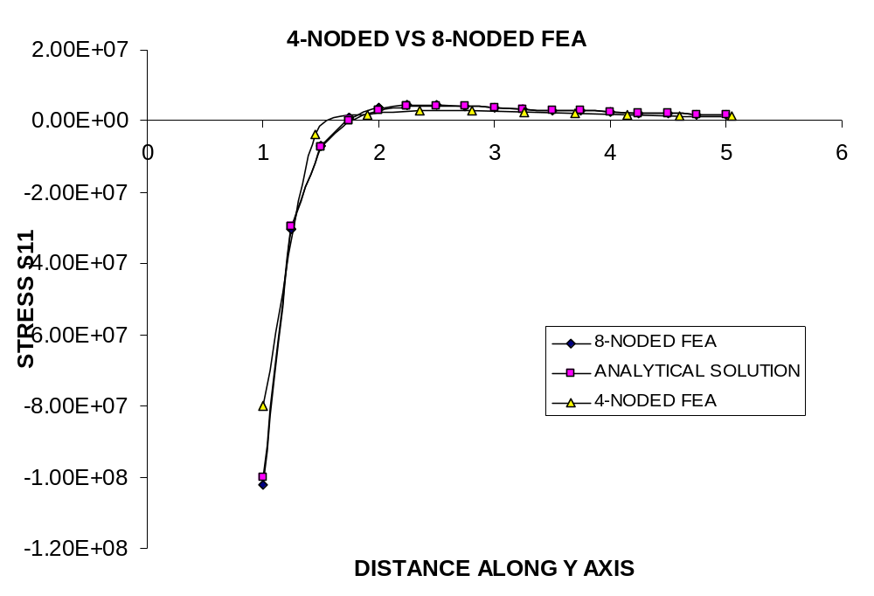
iii. Change the mesh density to continue comparing the performance of 4-noded and 8-noded FEA: 1173 nodes, 272 elements with 34 rows contained. Both x and y dimensions are prescribed to be 30 to ensure infinite condition. The second arc is at 6. Between Arc 1 and Arc 2, there are 30 rows and totally 240 elements.
For stress σ_{yy} :
X | S22 | S22-ANA | DISCRE%
1 | 3.02E+08 | 3E+08 | 0.528
1.166175 | 2.19E+08 | 2.18E+08 | 0.323328
1.166622 | 2.18E+08 | 2.18E+08 | 0.334761
1.332842 | 1.75E+08 | 1.76E+08 | -0.135874
1.333294 | 1.75E+08 | 1.76E+08 | -0.129389
1.499509 | 1.51E+08 | 1.52E+08 | -0.365513
1.499965 | 1.51E+08 | 1.52E+08 | -0.362617
1.666175 | 1.37E+08 | 1.37E+08 | -0.460147
1.666635 | 1.37E+08 | 1.37E+08 | -0.458492
1.832842 | 1.28E+08 | 1.28E+08 | -0.481396
1.833304 | 1.28E+08 | 1.28E+08 | -0.480777
1.999509 | 1.21E+08 | 1.22E+08 | -0.46382
1.999973 | 1.21E+08 | 1.22E+08 | -0.462638
2.16618 | 1.17E+08 | 1.17E+08 | -0.426734
2.16664 | 1.17E+08 | 1.17E+08 | -0.426509
2.33284 | 1.14E+08 | 1.14E+08 | -0.381814
2.33331 | 1.14E+08 | 1.14E+08 | -0.381157
2.49951 | 1.11E+08 | 1.12E+08 | -0.334521
2.49998 | 1.11E+08 | 1.12E+08 | -0.333736
2.66618 | 1.10E+08 | 1.1E+08 | -0.287532
2.66665 | 1.10E+08 | 1.1E+08 | -0.287025
2.83284 | 1.08E+08 | 1.09E+08 | -0.242929
2.83331 | 1.08E+08 | 1.09E+08 | -0.243295
2.99951 | 1.07E+08 | 1.07E+08 | -0.201501
2.99998 | 1.07E+08 | 1.07E+08 | -0.201597
3.16618 | 1.06E+08 | 1.06E+08 | -0.163693
3.16665 | 1.06E+08 | 1.06E+08 | -0.163353
3.33284 | 1.06E+08 | 1.06E+08 | -0.128694
3.49951 | 1.05E+08 | 1.05E+08 | -0.096038
3.66618 | 1.04E+08 | 1.05E+08 | -0.066282
3.83284 | 1.04E+08 | 1.04E+08 | -0.039924
3.99951 | 1.04E+08 | 1.04E+08 | -0.014454
4.16618 | 1.03E+08 | 1.03E+08 | 0.008155
4.33284 | 1.03E+08 | 1.03E+08 | 0.028202
4.49951 | 1.03E+08 | 1.03E+08 | 0.046063
4.66618 | 1.03E+08 | 1.03E+08 | 0.062562
4.83284 | 1.02E+08 | 1.02E+08 | 0.077416
4.99951 | 1.02E+08 | 1.02E+08 | 0.089508
Plot 8-noded FEA vs Analytical solutions and compare the results with that of 4-noded case. 8-noded results are more accurate.
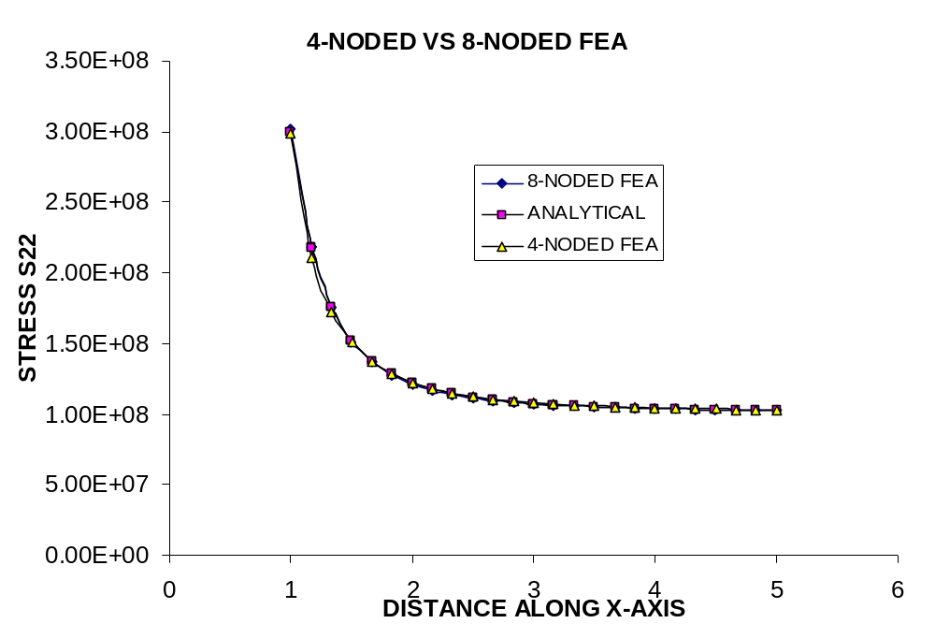
For stress σ_{xx} :
Y | S11 | S11-ANA | DISCRE%
1 | -1.01E+08 | -1E+08 | 1.061
1.166175 | -4.46E+07 | -44337218 | 0.538783
1.166622 | -4.45E+07 | -44241158 | 0.578968
1.332842 | -1.88E+07 | -19385220 | -2.85537
1.333294 | -1.88E+07 | -19339879 | -2.82359
1.499509 | -6.64E+06 | -7431679 | -10.62195
1.499965 | -6.62E+06 | -7409136 | -10.62251
1.666175 | -633153 | -1452331 | -56.40437
1.666635 | -622307 | -1440793 | -56.80804
1.832842 | 2.37E+06 | 1591985 | 48.62138
1.833304 | 2.37E+06 | 1597878 | 48.43626
1.999509 | 3.82E+06 | 3121928 | 22.5102
1.999973 | 3.83E+06 | 3124831 | 22.4927
2.16618 | 4.47E+06 | 3843071 | 16.28357
2.16664 | 4.47E+06 | 3844330 | 16.28267
2.33284 | 4.67E+06 | 4122885 | 13.3745
2.49951 | 4.64E+06 | 4160125 | 11.60362
2.66618 | 4.49E+06 | 4065342 | 10.34643
2.83284 | 4.27E+06 | 3901363 | 9.355625
2.99951 | 4.02E+06 | 3704309 | 8.514447
3.16618 | 3.77E+06 | 3495064 | 7.760834
3.33284 | 3.52E+06 | 3285613 | 7.058874
3.49951 | 3.28E+06 | 3082632 | 6.387973
3.66618 | 3.06E+06 | 2889694 | 5.736469
3.83284 | 2.85E+06 | 2708485 | 5.097516
3.99951 | 2.65E+06 | 2539541 | 4.470451
4.16618 | 2.47E+06 | 2382776 | 3.856161
4.33284 | 2.31E+06 | 2237729 | 3.258695
4.49951 | 2.16E+06 | 2103716 | 2.686848
4.66618 | 2.02E+06 | 1979991 | 2.149461
4.83284 | 1.90E+06 | 1865778 | 1.658905
4.99951 | 1.78E+06 | 1760298 | 1.230022
Plot 4-noded and 8-noded FEA results vs analytical solution: 8-noded is superior.
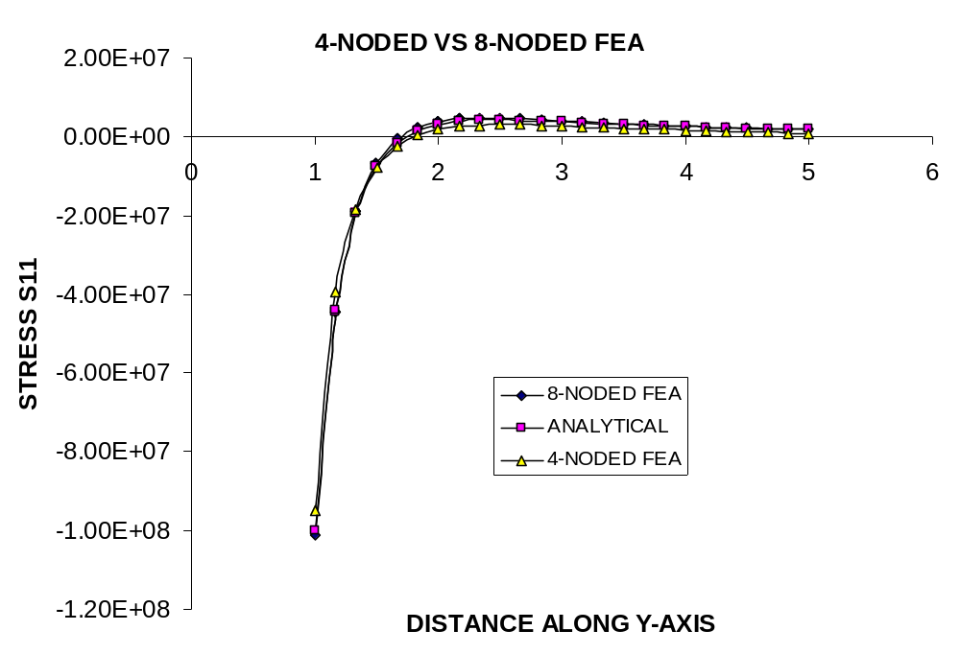
3.3 Use FEA to determine the stress concentration factor for the problem of a hole in a plate of finite width, where the hole diameter is 80% the width of the plate. Illustrate that your mesh is convergent (i.e. that you have the right answer.)
Solution: 4-noded elements are applied.
According to the question, it is expected that the stress near the edge of the hole on the x axis (which is the maximum) should converge to a certain value after the mesh is modified with finer elements. Therefore, the geometry of the plate is prescribed as follows: width of the plate to be 20, and radius of the hole to be 16 (80% of the width of the plate).
8 scenarios for different mesh geometry have been studied to validate the convergence.
I. 5 rows and 40 elements with 54 nodes:
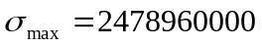 and 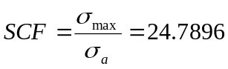
II. 10 rows and 80 elements with 99 nodes:
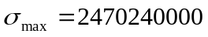 and 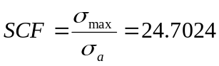
III. 20 rows and 160 elements with 189 nodes:
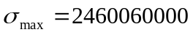 and 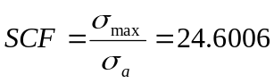
IV. 40 rows and 320 elements with 369 nodes:
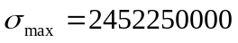 and 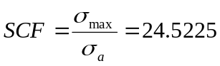
V. 50 rows and 400 elements with 459 nodes:
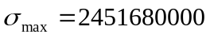 and 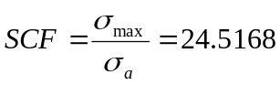
VI. 60 rows and 480 elements with 549 nodes:
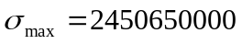 and 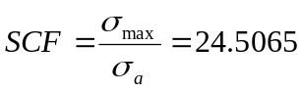
VII. 80 rows and 640 elements with 729 nodes:
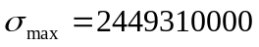 and 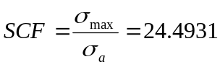
VIII. 100 rows and 800 elements with 909 nodes:
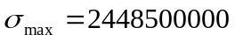 and 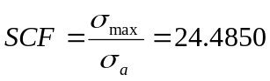
Plot the results. It is seen that both the results of the maximum stress and the stress concentration factor are convergent.
